**Visvesvaraya Technological University**

**jnana sangama, Belagavi-590018**



**A Seminar Report**

**on**

***“RFID Based Student Attendance Management System”***

*Submitted in partial fulfilment of the requirements for the VIII Semester,* ***Bachelor of Engineering in Computer Science and Engineering***

*of Visvesvaraya Technological University, Belagavi*

Submitted by:

**R SAIPRASANTH**

**(1RN14CS075)**



**Department of Computer Science and Engineering**

**RNS Institute of Technology**

**Channasandra, Dr. Vishnuvaradana Road, Bengaluru-560 098**

**2017-2018**

**RNS Institute of Technology**

Channasandra, Dr. Vishnuvaradana Road,

Bengaluru-560 098

**Department of Computer Science & Engineering**



**CERTIFICATE**

Certified that the Seminar on topic **“RFID Based Student Attendance Management System”** has been successfully presented at **RNS** **Institute of Technology by R SAIPRASANTH,** bearing USN 1RN14CS075**,** in partial fulfilment of the requirements for the *VIII Semester, Bachelor* ***of Engineering in Computer Science and Engineering*** *of Visvesvaraya Technological University, Belagavi* during academic year 2017-2018. It is certified that all corrections/suggestions indicated for Internal Assessment have been incorporated in the report deposited in the departmental library. The Seminar report has been approved as it satisfies the academic requirements in respect of Seminar work for the said **degree.**

**Dr G T Raju Mr. Devaraju B M**

Prof, Guide Asst. Prof, Seminar Coordinator

**Dr G T Raju Dr M K Venkatesha**

Dean of Engg., Prof and Head Principal

# Abstract

In recent years, there have been rise in the number of applications based on Radio Frequency Identification (RFID) systems and have been successfully applied to different areas as diverse as transportation, health-care, agriculture, and hospitality industry to name a few.

RFID technology facilitates automatic wireless identification using electronic passive and active tags with suitable readers. Radio-frequency identification (RFID) is a technology that uses radio waves to transfer data from an electronic tag, called RFID tag or label, attached to an object, through a reader for the purpose of identifying and tracking the object. RFID technology which is a matured technology that has been widely deployed by various organizations as part of their automation systems. In this study, an RFID based system has been built in order to produce a time-attendance management system.

Radio frequency identification (RFID) is a matured technology that incorporates the use of electromagnetic or electrostatic coupling in the radio frequency portion of the electromagnetic spectrum to uniquely identify an object, animal, or person. RFID chips contain a radio transmitter that emits a coded identification number when queried by a reader device. Some RFID tags can be read from several meters away and beyond the line of sight of the reader. The application of bulk reading enables an almost-parallel reading of tags. This small type is incorporated in consumer products, and even implanted in pets, for identification. RFID can be used in many applications. A tag can be affixed to any object and used to track and manage inventory, assets, people, etc. For example, it can be affixed to cars, computer equipment, books, mobile phones, etc. The Healthcare industry has used RFID to reduce counting, looking for things and auditing items. Many financial institutions use RFID to track key assets and automate compliance.

Attendance plays a vital role in evaluating a student. The traditional method of taking attendance manually is very time consuming and often leads to human error. This paper elaborates the implementation of Radio Frequency Identification based Student Attendance Management System using Open Source Software in a multi-user environment. The system uses python as backend for reading tags. A JAVA based desktop application is used to authenticate lecturers, run the python code and record tags in an XML file. Finally, the XML file is uploaded in the server for processing and interpreting student’s attendance. User can view attendance by accessing the web portal.

Department of CSE, RNSIT2017-2018

# Acknowledgement

At the very onset I would like to place on regard my utter gratefulness to all those people who helped me in making this seminar a reality.

I would like to profoundly thank the **Management** of **R N S Institute of Technology** for providing such a healthy environment for the successful completion of this Seminar.

I would like to express my thank **Dr. H N Shivashankar, Director** and **Dr. M K Venkatesha,** **Principal,** for their encouragement that motivated me for the successful completion of this seminar.

I am extremely grateful to our beloved, **Dr. G T Raju**, **Dean of Engg, Professor and HOD, Department of Computer Science and Engineering,** for having accepted to patronize me in the right direction with all his wisdom.

I place my heartfelt thanks to **Prof. Devaraju B M, Technical Seminar Coordinator and Team members**. I would like to thank my Internal guide **Prof. Devaraju B M,** Asst. Prof., for his continuous guidance and constructive suggestions for this seminar work.

I Also thank all the staff members of Computer Science Department for encouragement and support.

On presenting the seminar report on **“RFID Based Student Attendance Management System”** I feel great to express my humble feelings to all who have helped me directly or indirectly in the successful completion of this work.

**R SAIPRASANTH**

**(1RN14CS075)**

Department of CSE, RNSIT2017-2018

# Contents

|  |  |  |  |  |  |
| --- | --- | --- | --- | --- | --- |
| **Sl.No** | | **Chapters** | | **Page No.** | |
| 1 | | Introduction | | 01 | |
| 2 | | Literature Survey | | 02 | |
| 3 | | Related Works | | 05 | |
| 4 | | System Architecture | | 04 | |
| 5 | | Hardware Considerations | | 06 | |
| 6 | | Implementation Details | | 07 | |
| 7 | | Conclusion  References | | 11  12 | |

# List of Figures

|  |  |  |
| --- | --- | --- |
| **Sl. No** | **Figures** | **Page No.** |
| 4.1 | Block Diagram Showing Client-Side Architecture | 04 |
| 4.2  4.3  5.1  6.1 | Block Diagram Showing Server-Side Architecture  State Transition Diagram  Block diagram of RFID attendance system  RFID - Flow Diagram | 05  06  07  09 |

# Introduction

RFID based Student Attendance Management system uses emerging technology that eliminates the problem faced in manual attendance entry and will prove to be more reliable and accurate. Radio Frequency Identification is a technology that uses radio waves to transfer data from an RFID tag, through a reader for the purpose of uniquely identifying a person. An RFID system consists of a tag and a reader. The RFID reader consists of an antenna and transceiver. The reader is usually on and continuously senses its range of operation. Whenever a tag enters its field of operation, the RFID reader transmits electromagnetic waves using antenna to communicate with the tag’s antenna. The tag’s antenna receives data from the reader, activates tag and reflects back the incident electromagnetic waves with RFID tag information. The transceiver in the reader receives data and passes them on to the controllers.

The RFID attendance system is an automatic embedded system used in taking attendance of registered persons in a particular organization. The RFID attendance system offers an organization, the efficiency and convenience associated with RFID technology at a low cost. This method is fast as well as simple. Each employee uses an RFID card and the reader records the data when the employee enters or exits. RFID devices and software must be supported by a sophisticated software architecture that enables the collection and distribution of location-based information in near real time. A complete picture of the RFID attendance system combines the RFID Tags and readers with access to global standardized database, ensuring real time access to up-to-date information on the card. The card contains a unique identification number called an electronic product code (EPC).

The system uses Php, MySQL, Java, Python, XML and Apache to gather the recording, storing and extracting student’s attendance. Java is used for developing desktop application for taking attendance, python to retrieve data read by RFID reader and XML to store read tag IDs temporarily in the client PC. The XML file is then sent to the server using SSH for further processing. PHP is used for developing the web portal for accessing attendance. RFID based Student Attendance Management System was built using Open Source Software which reduces the overall cost of development process.

# Literature survey

In the process of system development, literature reviews conducted to understand the theory, methods and technologies associated with systems that have been developed. Background research on the organization and comparative studies of existing systems is also done to understand the system requirements before the system was developed. Student Attendance Using RFID System is an automatic record of student attendance developed especially for universities. It’s generally said that the roots of radio frequency identification technology can be traced back to World War II. The Germans, Japanese, Americans and British were all using radar which had been discovered in 1935 by Scottish physicist Sir Robert Alexander Watson-Watt to warn of approaching planes while they were still miles away. RFID is commonly used to transmit and receive information without wires. RFID readers and tags communicate through a distance using radio waves. There are a lot of advantages in RFID system, included their price, size, memory capacity and their capability. Advances in radar and RF communications systems continued through the 1950s and 1960s. Electronic article surveillance tags, which are still used in packaging today, have a 1-bit tag. The bit is either on or off. If someone pays for the item, the bit is turned off, and a person can leave the store. But if the person doesn't pay and tries to walk out of the store, readers at the door detect the tag and sound an alarm. The First RFID Patents Mario W. Cardullo claims to have received the first U.S. patent for an active RFID tag with rewritable memory on January 23, 1973 [5]. Later, companies developed a low-frequency (125 kHz) system, featuring smaller transponders. Low frequency transponders were also put in cards and used to control the access to buildings. A reader in the steering column reads the passive RFID tag in the plastic housing around the key. If it doesn’t get the ID number it is programmed to look for, the car won't start [5]. In the early 1990s, IBM engineers developed and patented an ultra-high frequency (UHF) RFID system. UHF offered longer read range (up to 20 feet under good conditions) and faster data transfer. IBM did some early pilots with Wal-Mart, but never commercialized this technology. When it ran into financial trouble in the mid-1990s, IBM sold its patents to Intermec, a bar code systems provider. Intermec RFID systems have been installed in numerous different applications, from warehouse tracking to farming. But the technology was expensive at the time due to the low volume of sales and the lack of open, international standards.

# RELATED WORKS

Samuel King Opoku have underwent a project based on biometric system. Under this system, time and attendance software is paired with a time clock which uses biometric technology for authenticating employees. The employees can use their fingerprints for clocking in and clocking out. Similar technology was implemented by Simao, P. Fonseca, J. Santos, V with the help of two technologies namely Embedded system and Biometrics.

Arulogun O.T., Olatunbosun, A., Fakolujo O. A., and Olaniyi, O. have developed an RFID based Attendance System that are commonly used nowadays to keep track of attendance for community organizations such as educational institutions, business organizations etc. Similar project was undertaken by Nurbek Saparkhojayev and Selim Guvercin.

In 1945, Leon Theremin invented an espionage tool for the Soviet Union which retransmitted incident radio waves with audio frequency information. Sound waves vibrated a diaphragm which slightly altered the shape of the resonator, which modulated the reflected radio frequency even though this device was covert listening device, not an identification device or tag, it is considered to be a predecessor of radio frequency identification (RFID) technology because it was likewise passive, being energized and activated by waves from an outside source. Similar technologies such as the IFF (identification friend and foe) transponder developed in the United Kingdom, was routinely used by the allies in the World War 2 to identify aircrafts as friend or foe. Transponders are still used by most powered aircrafts to this day. Mario.W. Cardullo was the first to have received the United States patent for an active RFID tag with re-writable memory on January 23, 1973. In that same year, Charles Walton, a California entrepreneur, received a patent for a passive transponder used to unlock a door without a key. A card with an embedded transponder communicates a reader near a door, when the reader detects a valid identification number stored within the tag, the reader unlocks the door.

Arulogun O. T., Olatunbosun, A. , Fakolujo O. A. , and Olaniyi, O. M have developed an RFID based Attendance System that are commonly used nowadays to keep track of attendance for community organizations such as educational institutions, business organizations etc. Similar project was undertaken by Nurbek Saparkhojayev and Selim Guvercin.

# system architecture

## Client-side architecture

Time and attendance systems are a major part of today’s human resource systems, take organization towards better human resource practice, systems and excellence. The implementation of time and attendance system has a lot of advantages for the manager. The kind of system that is implemented depends upon what the organization is trying to achieve by implementing the system. There are different types of automatic attendance systems; each type of system is suited to different needs and requirements

The RFID reader is connected to client computer. The reader is usually on and continuously senses its field of operation. Whenever a tag enters its vicinity, it sends an electromagnetic wave to the tag. The tag reflects back the wave along with its unique identification number. The java application for taking attendance is executed using shell script. A lecturer needs to authenticate himself by logging into the system. If the response is positive, the lecturer is redirected to the ‘take attendance’ panel where he needs to enter the subject name for which he wants to take attendance. The subject name is validated using database and a python code is executed for reading tags, checking redundancy and creating an XML file containing tag IDs. The XML file is sent to the server for further processing. At the end the XML file is deleted from the client PC.

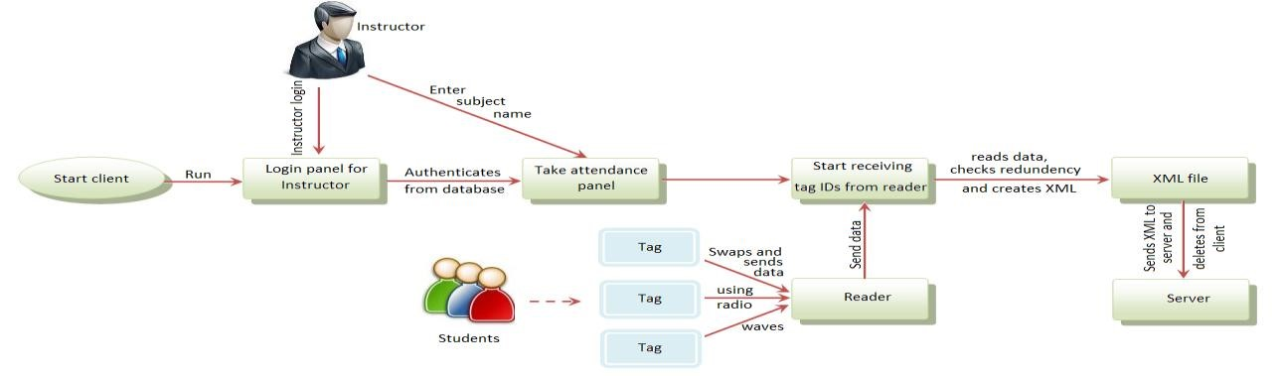

Figure 4.1 Block Diagram Showing Client-Side Architecture

## Server-side architecture

Figure 4.2 Block Diagram Showing Server-Side Architecture

The server fetches the XML file from client and parses the XML file to retrieve subject name and corresponding tag IDs. The tag IDs obtained are validated and attendance is stored in the database. The user can access the web portal for viewing attendance. The web portal in turn queries the server database and retrieves student attendance. Finally, the web portal respond users with the attendance.

## State Transition Diagram

The primary role of an administrator is to allocate tag IDs to student and monitor the entire system. Whenever a student wants a unique tag, he need to go to the administrator. The administrator selects a random tag and reads the tag ID. He logs into the system and assigns that tag ID against a particular student.

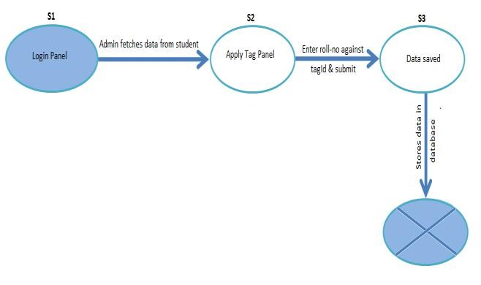

Figure 4.3 State Transition Diagram

# Hardware considerations

**Radio Frequency Identification (RFID**)

A radio-frequency identification system comprises hardware shown below. RFID tags are of two major types, which include Active Tag and Passive Tag.

RFID tags can be either passive, active or battery assisted passive. Passive RFID does not use a battery, while an active has an on-board battery that always broadcasts or beacons its signal. A battery assisted passive has a small battery on board that is activated when in the presence of a RFID reader. Most RFID tags contain at least two parts: one is an integrated circuit for storing and processing information, modulating and demodulating a radio-frequency (RF) signal, and other specialized functions; the other is an antenna for receiving and transmitting the signal. Depending on mobility, RFID readers are classified into two different types: fixed RFID and mobile RFID. If the reader reads tags in a stationary position, it is called fixed RFID. These fixed readers are set up specific interrogation zones and create a "bubble" of RF energy that can be tightly controlled if the physics is well engineered. This allows a very definitive reading area for when tags go in and out of the interrogation zone. On the other hand, if the reader is mobile when the reader reads tags, it is called mobile RFID. The block diagram is shown below

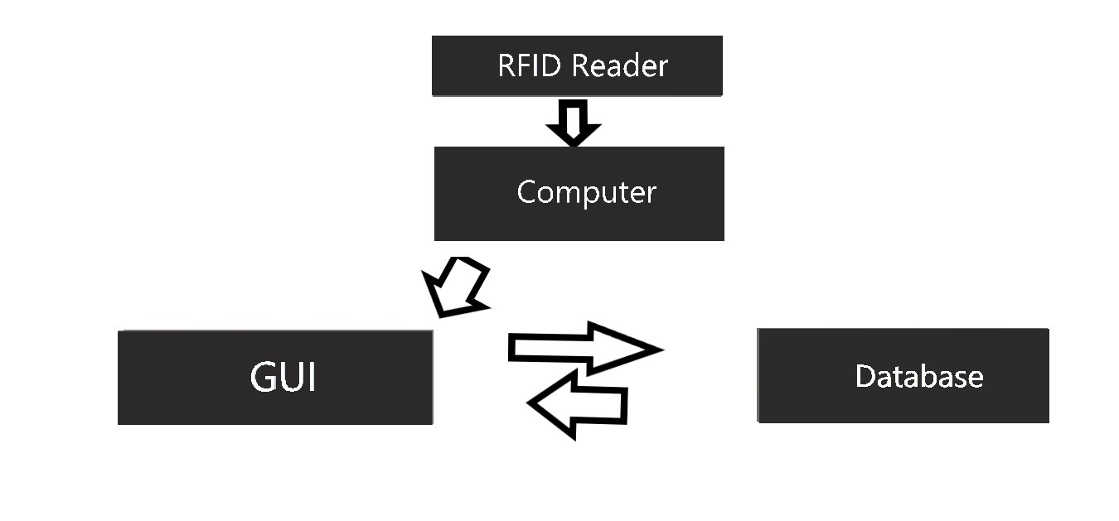

Figure 5.1 Block diagram of RFID attendance system

# Implementation details

## Creating Database

The database is designed with the help of ‘Lamp’ server. The tables generated are in normalized form, hence there is no data redundancy

## Creating Client-Side GUI for taking attendance

The GUI is created using Java. A lecturer needs to authenticate himself by entering his username and password. The password entered is converted to md5 hash and is authenticated by querying the database. If the response is positive, it is redirected to ‘take attendance panel’ where the lecturer needs to enter the subject name for which he wants to take attendance. The subject name is also validated using database. If it matches, the java runs a python code for taking attendance for that particular subject.

## Reading the RFID Reader using serial port

RFID tags can be either passive, active or battery assisted passive. Passive RFID does not use a battery, while an active has an on-board battery that always broadcasts or beacons its signal. A battery assisted passive has a small battery on board that is activated when in the presence of a RFID reader. Most RFID tags contain at least two parts: one is an integrated circuit for storing and processing information, modulating and demodulating a radio-frequency (RF) signal, and other specialized functions; the other is an antenna for receiving and transmitting the signal. Depending on mobility, RFID readers are classified into two different types: fixed RFID and mobile RFID. If the reader reads tags in a stationary position, it is called fixed RFID. These fixed readers are set up specific interrogation zones and create a "bubble" of RF energy that can be tightly controlled if the physics is well engineered. This allows a very definitive reading area for when tags go in and out of the interrogation zone. On the other hand, if the reader is mobile when the reader reads tags, it is called mobile RFID.

*RFID Frequency band*

Frequency refers to the size of the radio waves used to communicate between the RFID system’s components. It can be assumed that higher frequency resulting faster data transfer rate and longer reading distance. However, as frequency increases, the sensitivity to environmental

factor also increases. RFID system currently operates at Low Frequency, High Frequency and Ultra High Frequency. Generally, a lower frequency means a lower read range and slower data read rate, but increased capabilities for reading near or on metal or liquid surfaces.

The RFID tag can be read from a distance and the embedded electronic information for each card can be over written repeatedly. This increases technologies like surveillance cameras to be activated in conjunction with an employee being in their vicinity. The RFID attendance system is faster and does not require line of sight. The RFID system has higher data storage. In the RFID systems, the transponders are also easy to conceal or incorporate in other items. For example, in 2009, researchers successfully glued RFID micro transponder to live ants in order to study their behaviour. Furthermore, multiple RFID cards can be read all at the same time. Information about the employees’ access and attendance can be stored on the database. In 2010 three key factors drove a significant increase in RFID usage. They include; decreased cost of equipment and tags, increased performance to a reliability of 99.9% and a stable international standard around UHF passive tag. The areas of significant use are financial services for Information Technology asset tracking and healthcare with more than 60% of the top medical device companies using passive UHF RFID in 2010. RFID is becoming increasingly prevalent as the price of the technology decreases.

The java file executes python code for taking attendance. The python code creates a List for storing data in an orderly manner. The subject name is appended at the beginning of the List. Then the code reads tag ID using serial port. The read tag IDs are inserted at the end of the List. This process of taking attendance continues for fifteen minutes.

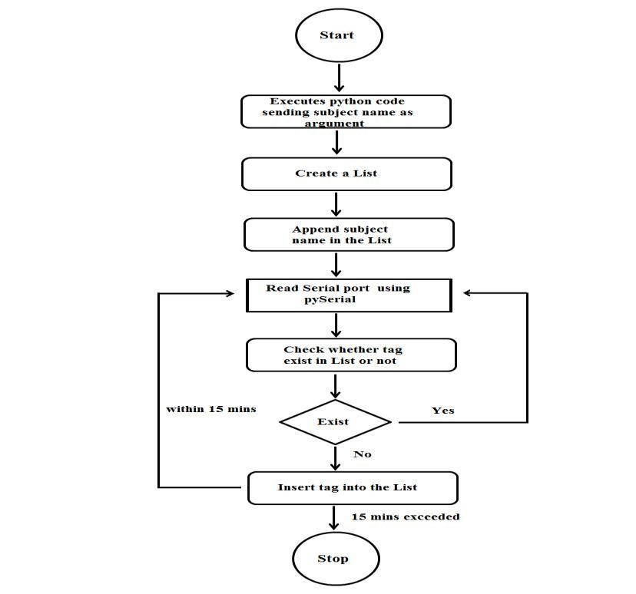

Figure 6.1 RFID - Flow Diagram

## Creating XML file for storing tagIDs temporarily

An XML file is created using python. The root node is chosen as ‘root’ and the subject name is inserted in the tree. Finally, the tagIDs in the List are stored in the XML file.

## Sending XML file to server

The XML file created in the client was sent to the server for further processing. The client was connected to the server using SSH and file was transferred successfully.

\

## Parsing the XML file and storing in the database

The XML file received by the server was parsed using Php. The total number of classes for that particular subject was incremented by one and the tagIDs found in the XML file for that particular subject were marked present.

## Creating server-side GUI for storing and retrieving information from server

The web portal for viewing attendance was created using HTML, CSS, JavaScript and Php. The student can access the web portal for viewing attendance by entering his roll number and subject name. The attendance will be calculated by querying the database and calculating the percentage based on total number of classes held for that subject and the number of classes attended by the student.

# Conclusion

The objective to build an Open Source based RFID Attendance Management system which increases performance and efficiency was successfully achieved. The system offers data manipulation and retrieval via an interface, making it a user-friendly attendance system. The system built is flexible, cost effective due to use of open source software and can be extended by adding more modules.

In terms of performance and efficiency, this project has provided a convenient method of attendance marking compared to the traditional method of attendance system. By using databases, the data is more organized. This system is also a user-friendly system as data manipulation and retrieval can be done via the interface, making it a universal attendance system. Thus, it can be implemented in either an academic institution or in organizations. However, some further improvements can be made on this RFID in order to increase its reliability and effectiveness. By incorporated an indicator or an LCD screen in the system to indicate when an unregistered card is scanned. An IP camera can be integrated into this system to enable the monitor to view the person who makes the transaction to avoid a problem of a person scanning in for another person. A reminder alert also can be developed to effectively track any ID that has been absent for an unacceptable time in a row.

Further improvement can be undertaken on this project for better enhancement: A webcam can be integrated into the system to monitor the person who swaps the card, thus avoiding the problem of a person scanning in for another person. The attendance system can be enhanced to biometric technology which is a full proof technique that captures a person’s unique biological or physical features and prevents unauthorized activities.

# References

[1] Samuel King Opoku, March 2013, “An automated biometric attendance management system,” International Journal of Computer Science and Mobile Computing., Vol. 2, Issue. 3, pp.18 – 25

[2] Simao, P. Fonseca, J. Santos, V., 2008, “Finger print based attendance system,” IEEE Internation Symposium on Consumer Electronics, ISCE ISBN-978-4244-2422- 1, pp. 1-4

[3] Arulogun O. T., Olatunbosun, A., Fakolujo O. A., and Olaniyi, February-2013, “RFID based student attendance management system,”. International Journal of Scientific & Engineering Research Volume 4, Issue 2, ISSN 2229-5518, pp. 1-9

[4] Nurbek Saparkhojayev, Selim Guvercin, May 2012, “Attendance control system based on rfid technology,” IJCSI International Journal of Computer Science Issues, Vol. 9, Issue 3, No 1, ISSN (Online): 1694-0814

[5] Sumita Nainan, Romin Parekh, Tanvi Shah, January 2013, “RFID Technology Based Attendance Management System,”. IJCSI International Journal of Computer Science Issues, Vol. 10, Issue 1, No 1, ISSN (Online): 1694-0814

[6] RohitChandrashekar, JayashreeShinde, Dashrath Mane, July 2013, “Importance and Analysis of RFID in Attendance System” . International Journal of Emerging Science and Engineering (IJESE), ISSN: 2319-6378, Vol. 1, Issue 9

[7] Ononiwu G. Chiagozie, Okorafor G. Nwaji, March 2012, “Radio Frequency Identification (RFID) based Attendance System with Automatic Door Unit”. Academic Research International, ISSN-L: 2223-9553, ISSN: 2223-9944, Vol. 2, No. 2

[8] Abdul Aziz Mohammed, Jyothi Kameswari, May 2013, “Web-Server based Student Attendance System using RFID technology”. International Journal of Engineering Trends and Technology (IJETT), Vol. 4, Issue. 5

[9] Sahana S Bhandari, June 2013, “Embedded Based Automated Student Attendance Governing System”. International Journal of Engineering and Advanced Technology(IJEAT), ISSN: 2249-8958, Vol. 2, Issue. 5

[10] A. Parvathy, B. Rajasekhar, C. Nithya, K. Thenmozhi, J.B.B. Rayappan, Pethuru Raj, Rengarajan Amirtharajan, “RFID in cloud environment for Attendance Monitoring System”. International Journal of Engineering and Technology (IJET), ISSN: 0975-4024

[11] Ankita Agrawal, Ashish Bansal, “Online Attendance Management System Using RFID with Object Counter”. International Journal of Information and Computation Technology, ISSN: 0974-2239, Vol. 3, Number 3 (2013), pp. 131-138

|  |
| --- |
| [12] “Internet of Things for Smart Cities” Andrea Zanella, Nicola Bui, Angelo Castellani, Lorenzo Vangelista, Senior Member, Michele Zorzi, Fellow, The final version of this manuscript will appear in the IEEE Internet Of Things Journal, vol. 1, no. 1, Feb. 2014. http://www.dei.unipd.it/~zanella/PAPER/CR_2014/IoTSmartCity2014_ CR.pdf on 20th Nov 2015. |
| [13] https://www.academicexperts.org/conf/elearn/2015/papers/47532 retirved on 20th Nov 2015, entitled “The Internet of Things in ELearning” by Joseph M Woodside, Shahram Amiri, William Sause, under topic tools & system. |
| [14] “Can the Internet of Things make education more student-focused?” by Max Meyers, Deloitte Consulting LLP retrieved from http://government2020.dupress.com/can-internet-things-make-education-student-focused/ on 10th Dec 2015 |
| [15] “Investing in an Internet of Things (IoT) Solution: Asking the Right Questions to Minimize TCO” by IDC Custom Solutions and sponsored by Aeris Communications in January 2014 retrieved from www.idc.com |